GPIO(26) => oLed0 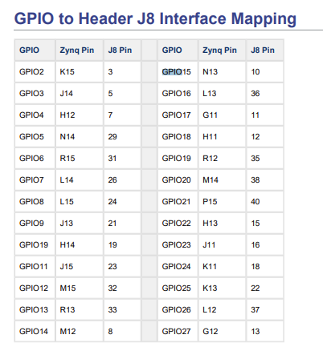

GPIO(19) => oLed1

GPIO(13) => oLed2

GPIO(6) => oLed3

GPIO(22) => iBTN0

GPIO(27) => iBTN1

GPIO(17) => iBTN2

GPIO(23) => oLCD_SDA

GPIO(24) => oLCD_SCL

GPIO(16) => oADC_SDA

GPIO(20) => oADC_SCL

GPIO(21) => oPwm

GPIO(25) => oClk_gen

